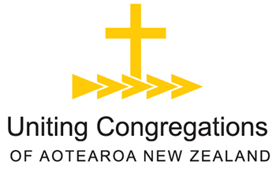
06 December 2018

A BRIEF SUMMARY OF RECENT DEVELOPMENTS FOR COOPERATIVE VENTURES
Amendments to the regulations for uniting congregations, Procedures for Cooperative Ventures, have been agreed by the Anglican, Christian Churches, Methodist and Presbyterian Partner Churches this year (2018). Consequent to those amendments, there will be changes to the method of financial assessment for Cooperative Ventures from July 2019.
Financial assessment now attaches to the Convening Partner only, and this role now rotates automatically every three years (a change from the previous five). A new schedule of Convening Partners is being prepared with advice from the regional/diocesan partners. This will be advertised from March 2019 and take effect from 1st July 2019.
The Appointing Partner (previously a role of the Coordinating Partner) is still agreed by all the local church’s partners, in conjunction with the local church. There is no change to this process.
A single assessment will cover payment to the diocese (in Anglican years, where applicable) or to national and synod/presbytery levels (in Methodist or Presbyterian years). Assessment will be based on a percentage of net income of a church: that is, gross income less certain allowances which are outlined in the letter sent this first week of December to all Cooperative Ventures.

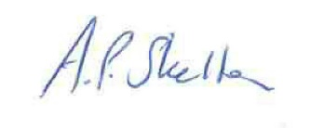
Rev Adrian Skelton
UCANZ Executive Officer
18 Eccleston Hill, Thorndon, Wellington
PO Box 12 046, Wellington 6144
Ph. 04 471 8593 Mobile 027 559 9042

